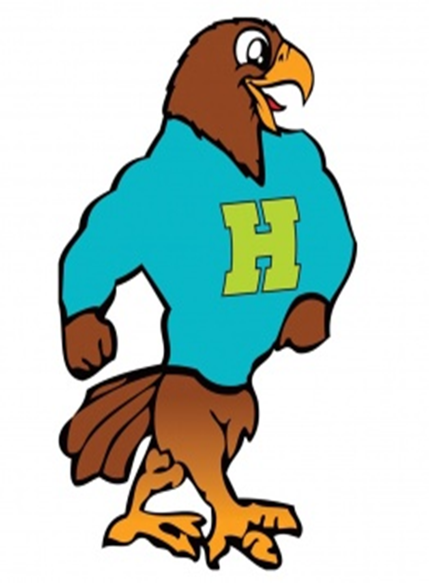

**Herbert Akins Road Elementary**

**Pre-K Supply List 2024 - 2025**

|  |  |  |
| --- | --- | --- |
| **Items NEEDED** | **Amount Needed** | **Notes** |
| Full Sized Backpack | 1 | Needs to fit a folder, lunchbox, blanket, and water bottle. |
| Small Blanket or Sheet for Rest Time | 1 | This blanket will remain at school for the year. Our laundry is small so please make sure the blanket or sheet is as well. If it is too big, we will send it home and request a smaller one. |
| Reusable Water Bottle | 1 | We do not encourage children to drink directly from the water fountain. This water bottle will be sent home each day to be washed. |
|  |  |  |
| ***Optional* Items** | **Amount Requested** | **Notes** |
| Crayola Crayons | 1 | 24 pack |
| Elmer’s Glue Sticks | 4 |  |
| Tissues | 2 |  |
| Paper Towels | 2 |  |
| Baby Wipes | 2 |  |
| Flushable Wipes | 2 |  |
| Bubbles | 2 |  |
| Chalk | 1 |  |
| Dry Erase Markers with Erasers on Lids | 1 |  |
| White Card Stock | 1 |  |
| Laminating Sheets | 1 |  |
| Ziploc Bags | 1 | All sizes needed  (Gallon, Quart, Sandwich, Snack) |